Workshop on ‘From Global to Coastal: Cultivating New Solutions and Partnerships for an Enhanced Ocean Observing System in a Decade of Accelerating Change’
Application Guidelines

Please follow the link from the webpage http://indico.ictp.it/event/9821/ and on the left-hand bar: "Apply Here" to enter the application system.
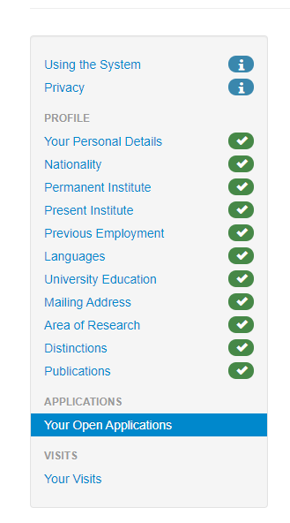
1. Personal Profile

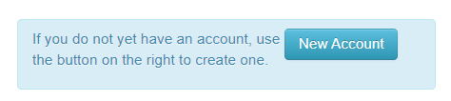
If this is your first time to apply through the ICTP system, you need to create a new account and complete your personal profile first, which may take you a few minutes. Please note that you need to fill in ALL the necessary parts of the profile, otherwise you will not be able to proceed the application. You could skip the items which have a ‘Leave empty’ button.

2. Apply to the Workshop

During your application process, you are able to:
- Indicate your preference of participation option;
- Apply financial assistance;
- Choose your interested topics;
- Indicate your Early Career Scientist status;
- Submit an abstract for your talk.
Again, you could skip the items which have a ‘Leave empty’ button. Please refer to the below snapshots for more details of each item.
* The deadline on 15 June 2022 is for abstracts submission and grant application and on 31 July 2022 is for all other applications.

Participation option. You could select your preference to attend either ‘In Presence’ or ‘Online’.
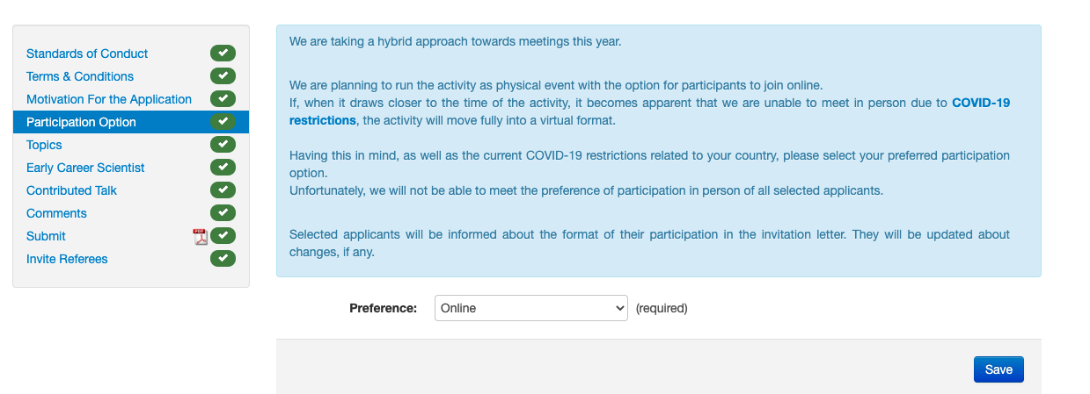
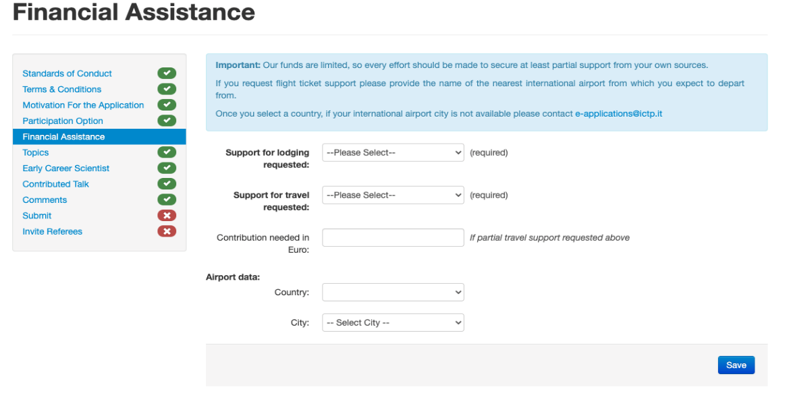
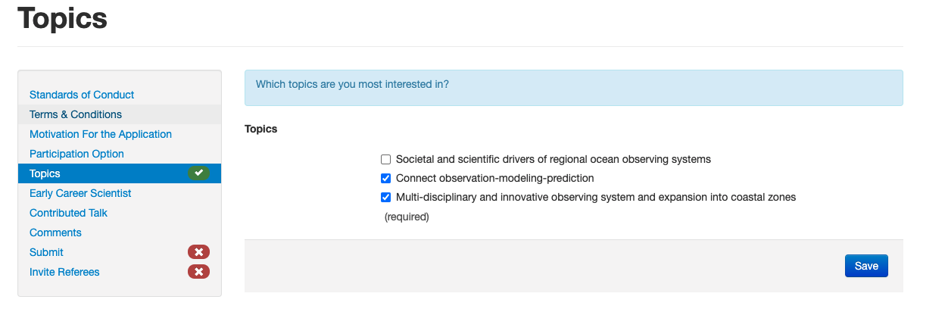
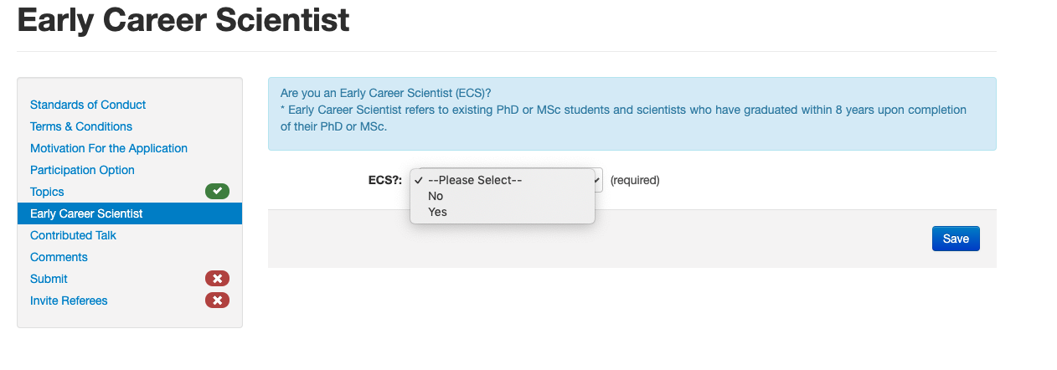
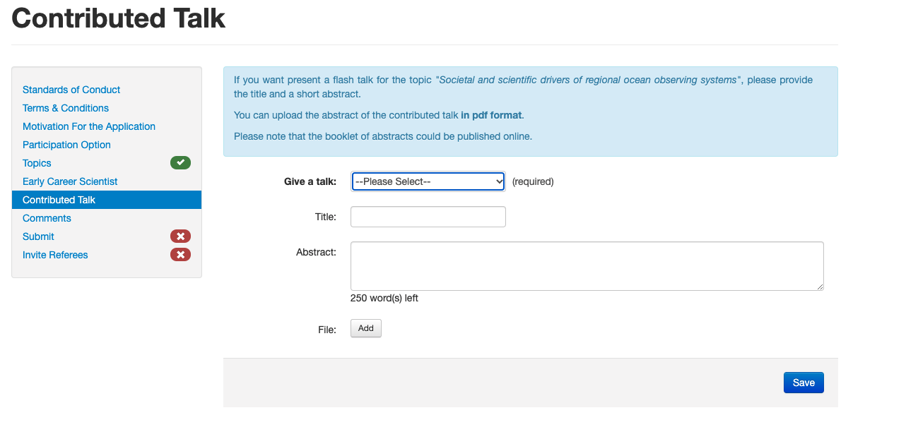
Please note that the referees and recommendation letters are not mandatorily required. However, if you think a recommendation letter would help your application, please feel free to invite a referee, by referring to the guidelines in the ‘Invite Referees’ section.

3. Result notification

A pdf document will be generated after you successfully submit your application. You can check the status of your application at any time by logging in into the system. Emails will be sent to notify the results of your participation or not to the workshop.

